**Figures**

Fig. 1. Isadora Duncan, by Paul Berger (1908). Irma Duncan Collection. Courtesy of the

Jerome Robbins Dance Division, The New York Public Library for the Performing Arts,

Astor, Lenox and Tilden Foundations.

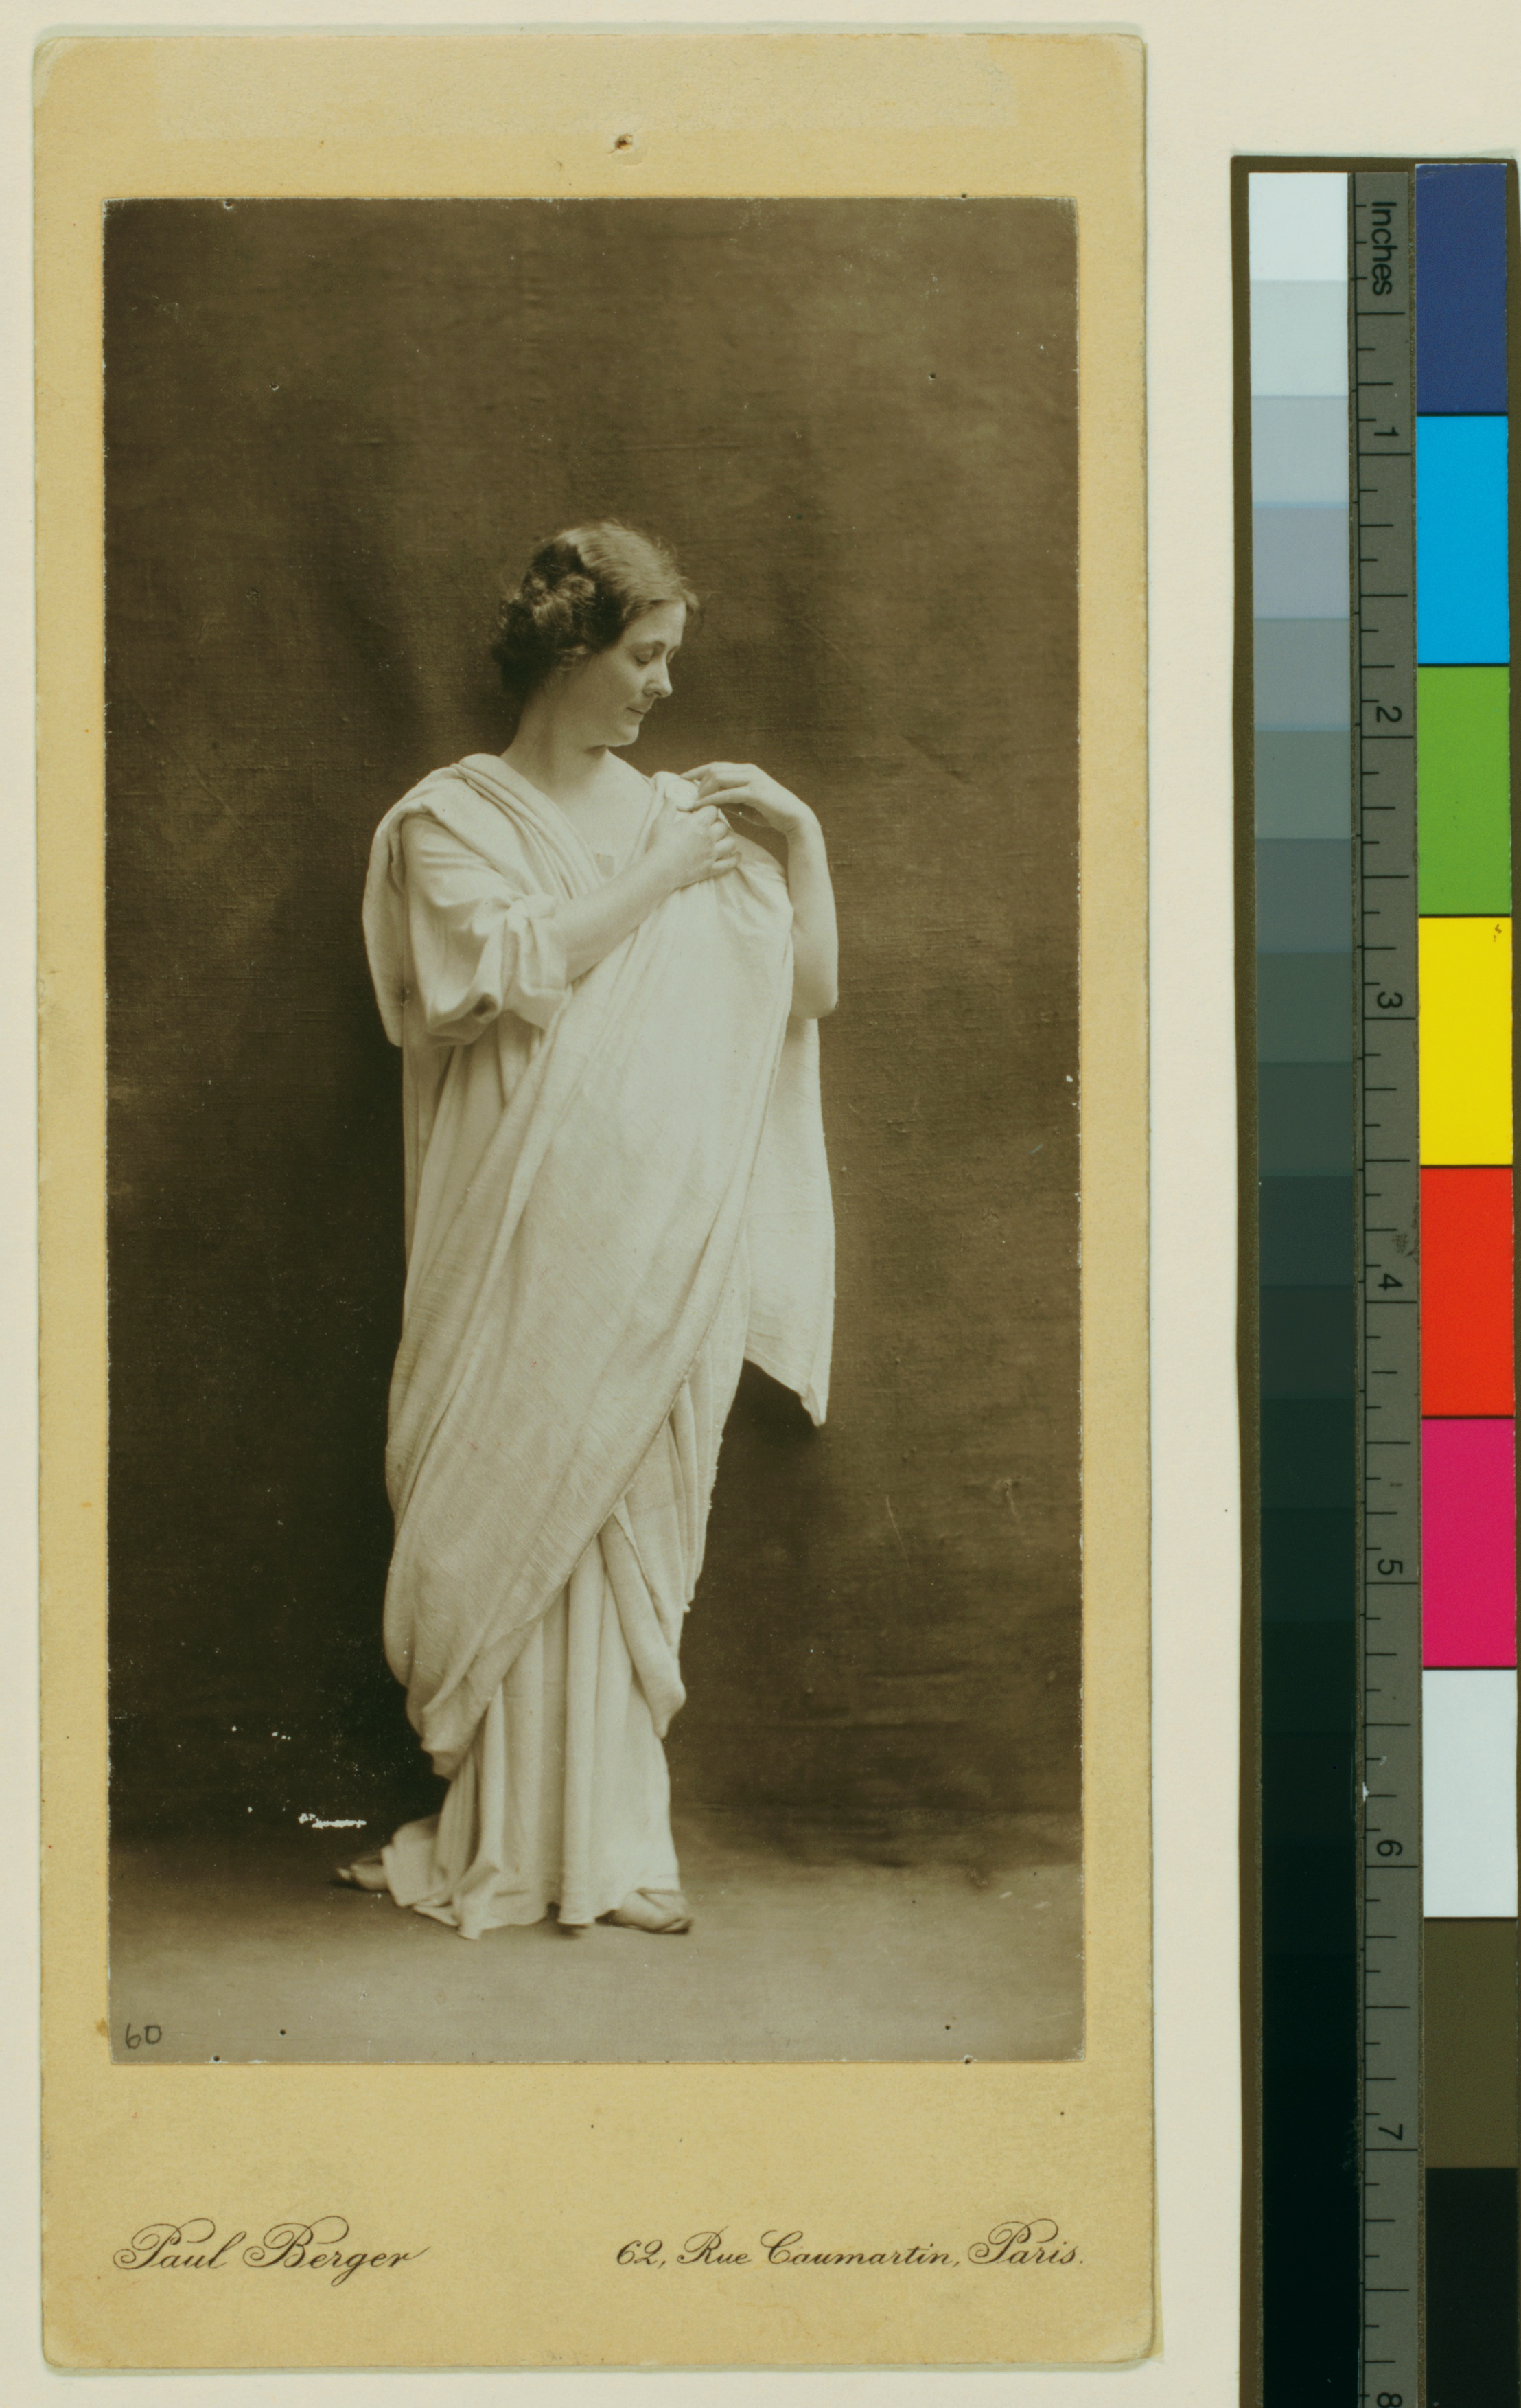

Fig. 2. Isadora Duncan in *Marseillaise* by Arnold Genthe (1915–1918). Courtesy of the Jerome Robbins Dance Division, The New York Public Library for the Performing Arts, Astor, Lenox, and Tilden Foundations.

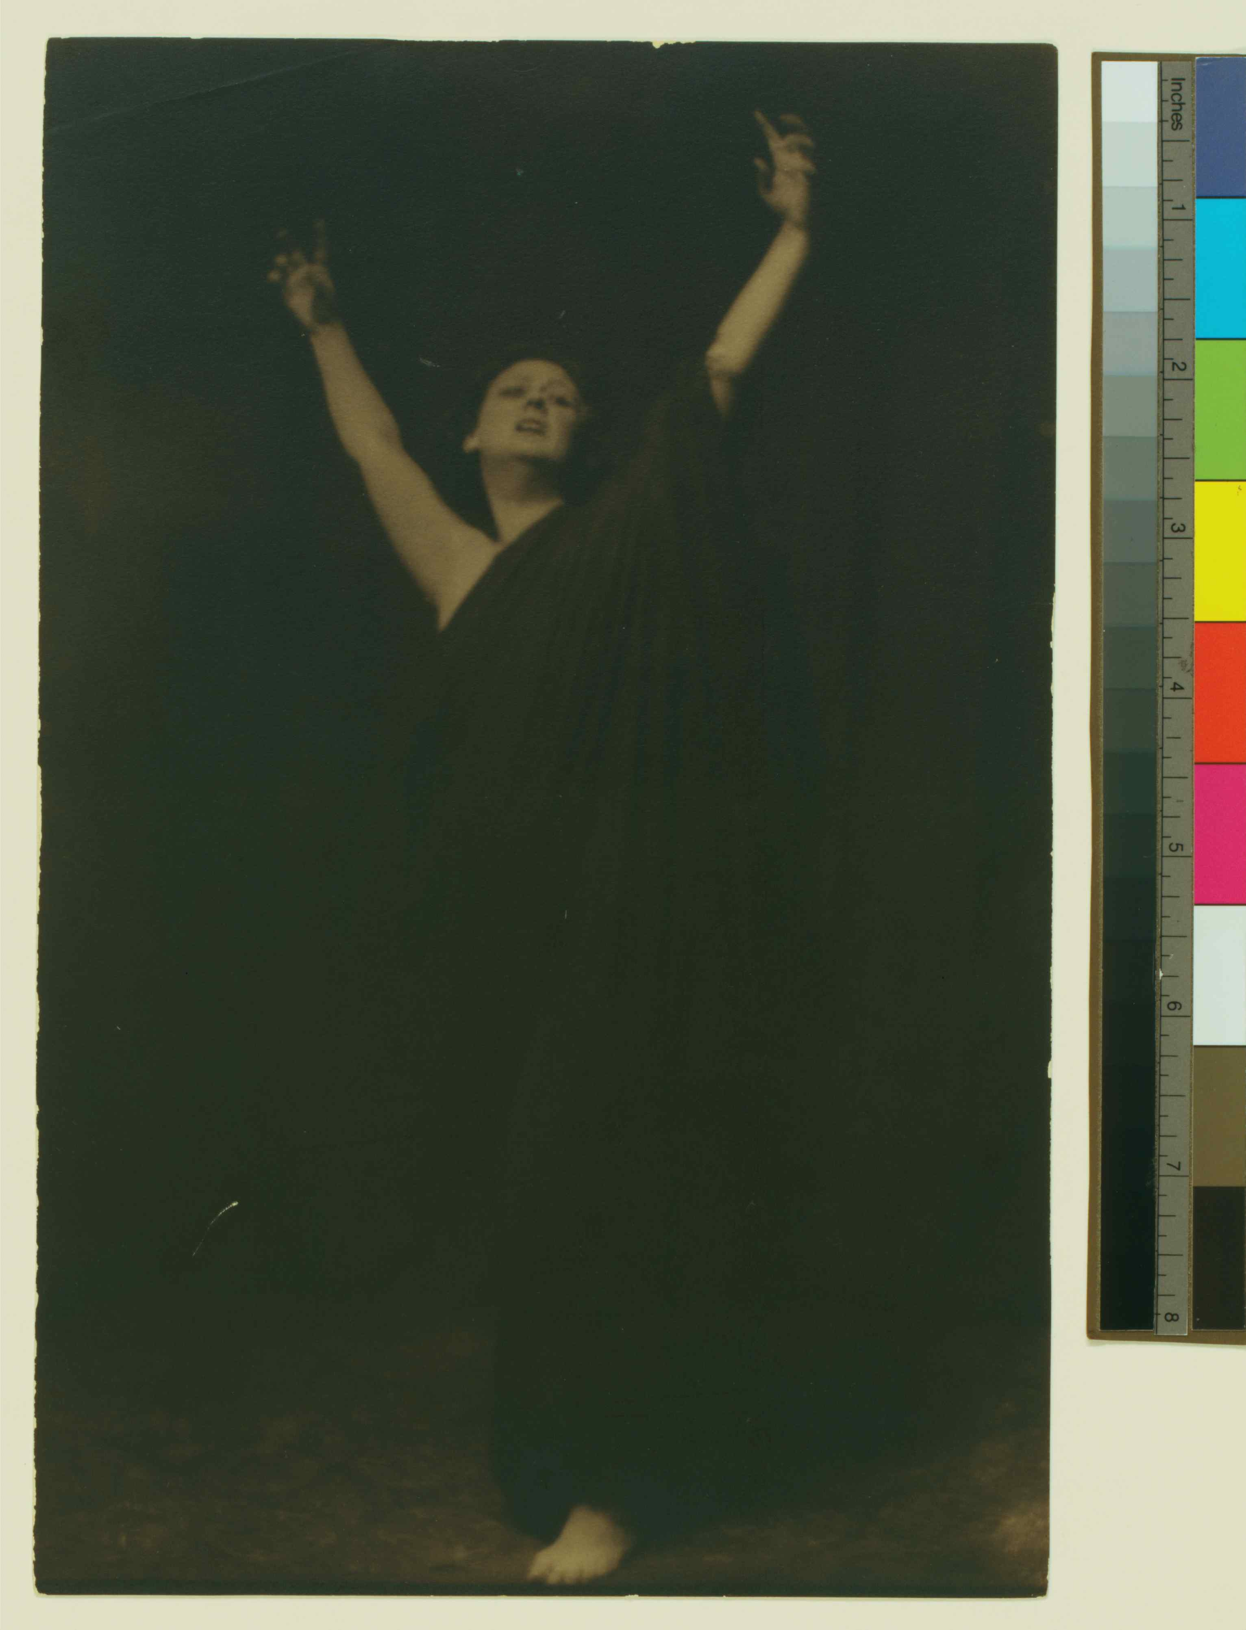

Fig 3. “Isadora Duncan in the *Marche Militaire*” by John Sloan. From the *Masses* (May 1915). © 2010 Delaware Art Museum/Artists Rights Society (ARS), New York. Photo courtesy of the Library of Congress.

